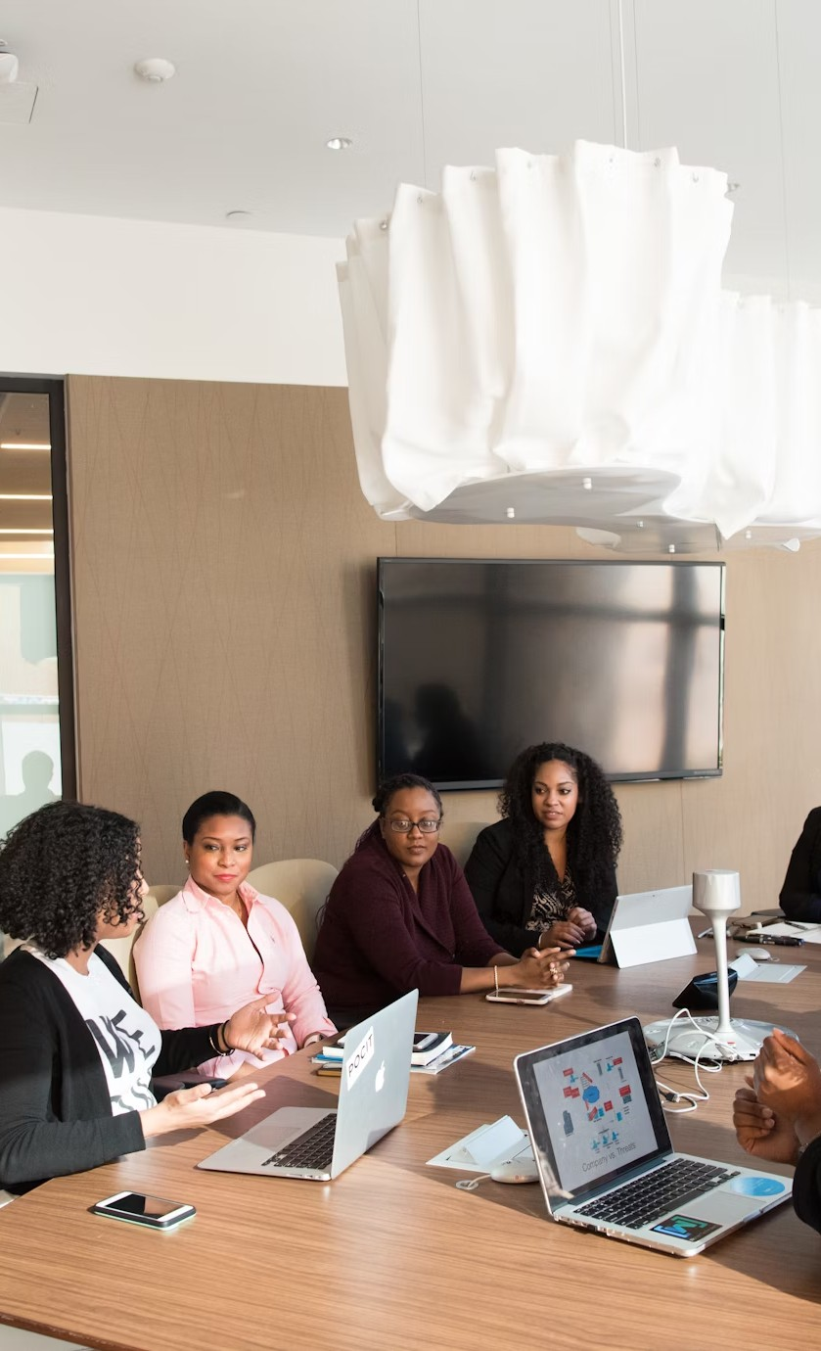

GACC

Global African Career Collective

NOV 2024

**Content**



*GACC*

Who we are Our story

**01**

**02**

**03**

**04**

**05**

**06**

**07**

The team

Our values

Sustainabilit y in GACC The networking event

Contact



We are a dedicated association empowering young anglophone African professionals in Europe. Through mentorship, networking, and collaboration, we bridge the gap between emerging talent and diversity- driven

companies.

Our **mission** is to create a supportive community that fosters professional growth, inclusivity, and

meaningful connections, inspiring each member to achieve their career aspirations.

*GACC*



Having l ived and worked in France for over f ive years, we understand the complexities of transitioning into a new

l inguistic and cultural professional landscape.

We quickly noticed that we were facing the same challenges in our professional journeys : integration, f inding professional opportunities, advocating for better remuneration etc.

We aim to harness our diverse experiences and synthesise them into a supportive framework for young African

professionals.

*GACC*

# The Team

## [Olive](https://www.linkedin.com/in/olive-kayitesi-468ba8131/) [Kayitesi](https://www.linkedin.com/in/olive-kayitesi-468ba8131/)

Chairperson

Sustainability Development

## [Mutethya](https://www.linkedin.com/in/mutethya-ivia/) [Ivia](https://www.linkedin.com/in/mutethya-ivia/)

##### Projects Manager

Cultural Policy & Media Researcher

## [Rachael](https://www.linkedin.com/in/rachaelngugi/) [Ngugi](https://www.linkedin.com/in/rachaelngugi/)

##### Communications Manager

Marketing and communications

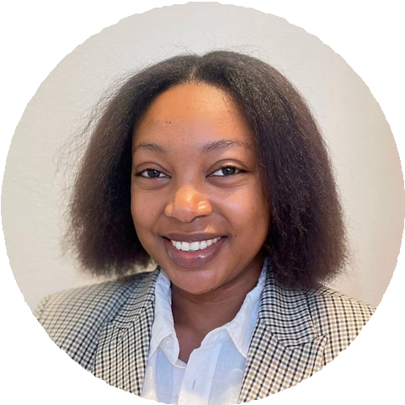

*GACC*

#### Empowerment

We Focus on equipping members with the skills, knowledge, and resources

necessary to advance their careers. This value highlights the importance of

mentorship, training, and support in fostering individual and collective growth.

#### Collaboration

We encourage a spirit of cooperation and networking among members to

foster mutual success. We recognize that collective efforts lead to greater opportunities and achievements.

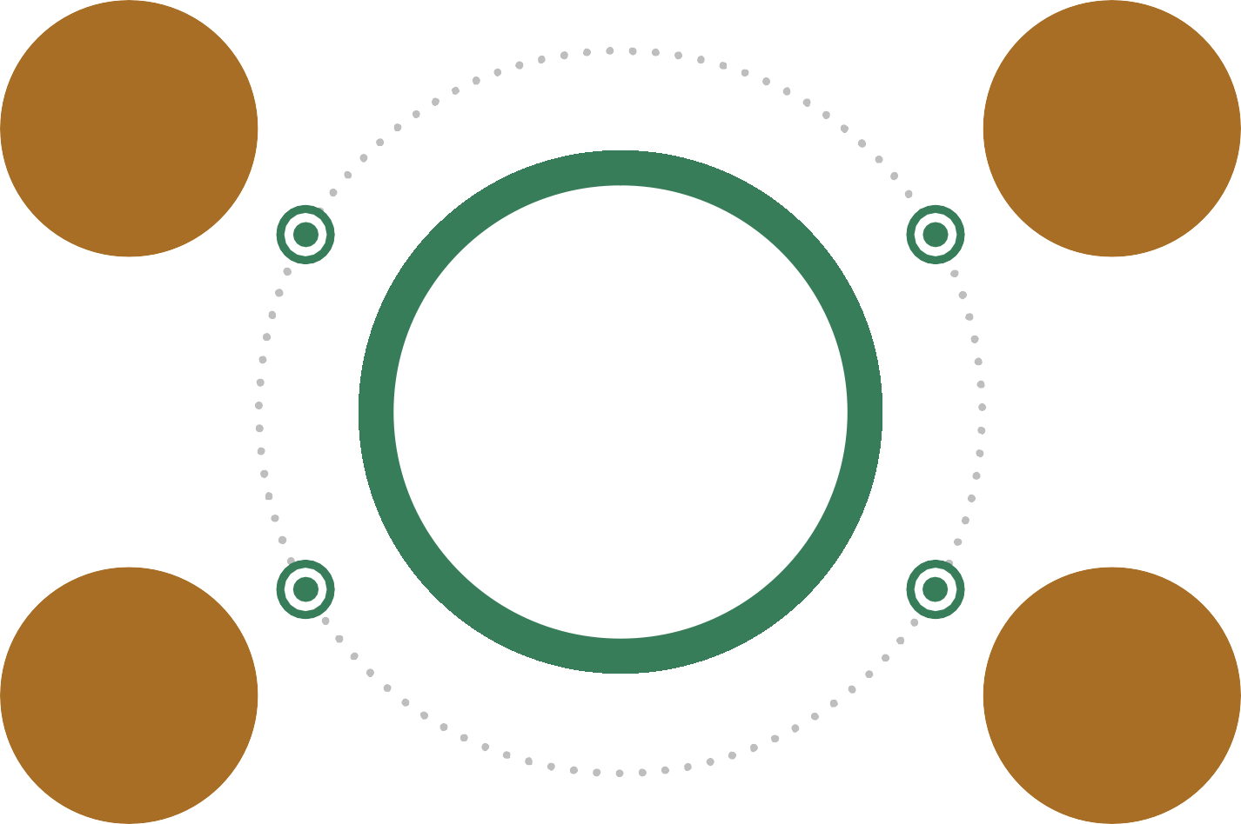

**Our**

**Values**

#### Cultural Synergy

GACC celebrates the fusion of African and global cultures, recognizing the

unique perspectives and strengths

that arise from this intersection. We champion the idea that embracing

cultural diversity enhances

professional and personal growth.

#### Global Connectivity

We recognize the importance of a global perspective in professional development. We encourage our members to leverage their unique backgrounds and experiences to

engage with global networks, creating opportunities that extend beyond

local boundaries.

*GACC*

# Sustainable Development

GACC aligns with the UN

Sustainable Development Goals

( SDGs). We specifically champion:

**08 10 17**

We purpose to promote decent work conditions ( SDG 8 ) by

connecting members to diverse career opportunities,

We aim to reduce

inequalities ( SDG 10 ) by advocating for workplace

inclusion and equal access

We work to foster global

collaboration ( SDG 17 ) through partnerships with diversity- driven

companies and institutions.



*GACC*

### Guest speakers

Learn from the movers and shakers across different

industries.

**GACC**

**Networking Event**

GACC welcomes you to the **monthly**

networking events held in Paris and soon in

cities across Europe!

For a small attendance fee, attendees can

look forward to:

*GACC*

### Mentorship opportunities

Get matched with a mentor to take their career to the next

level.

### Speed networking

Quick- f i re sessions for l ike- minded young professionals to form

meaningful contacts

### Cocktail hour

Tasty bites will be made

available at every networking event



**THANK YOU**

contact@gacc.com